GSoC 2013 Documentation 24 July 2013

Adding logo to BIRT report dynamically

Open BIRT report in BIRT designer. Drag and drop Image report item on the layout.

Click on the XML source tab at the bottom and find ‘Image’ tag. Specify the ‘height’ and ‘width’ properties.

Double click on the ‘Image’ item in the Layout tab. The following window opens:

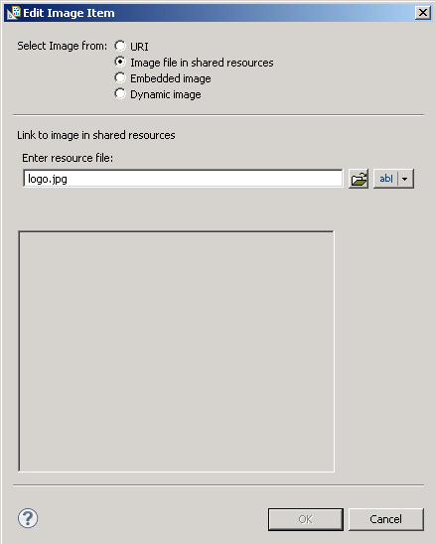
Figure: Edit Image Item

Select “Image file in shared resources”. With this option, we are instructing the BIRT report to look for the image in the ‘shared resources’. The shared resources location will be specified in the code later. Enter the name “logo.jpg” for the image. Click OK.

Click on ‘Script’ tab. Select “On Create” method from the top and write the following in the editor:
this.file="logo.jpg";

Save the report and place it in the ZAP code at src\ reportdesignfiles

Then in the source code, another top menu is added “Upload BIRT Report logo”. On clicking this menu item, a dialog box appears to browse to the logo, a user would like to place on the report as shown in the following figure:

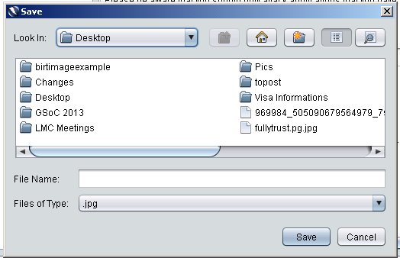
Figure: Upload image

When the user selects the image of .jpg extension and click on the “Save” button, the code saves the image with name “logo.jpg” in the folder ‘bin/reportdesignfiles’. So, whatever the name of the uploaded image, it will be saved in the shared resources location with the name “logo.jpg”.

Also, in the source code, the shared resources folder path is specified to be the ‘bin/reportdesignfiles’. This is done via the method EngineConfig.setResourcePath() method in the ReportEngine class.

When the user clicks on the menu item “Generate BIRT report pdf”, the BIRT report template loads the logo image from the shared resources path and place that in the pre-defined width and height for the logo image.

